# How to configure ERA to provision Postgres database

## Product Configuration:

* Calm 3.2
* ERA 2.1.1.1

## Adapt the blueprint to your local environment

### Import the blueprint

1. Click on Upload Blueprint

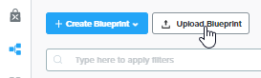

1. Choose a Project
2. Key in nutanix/4u for the passcode

### Credential

1. Fill in the following credentials to suit your environment

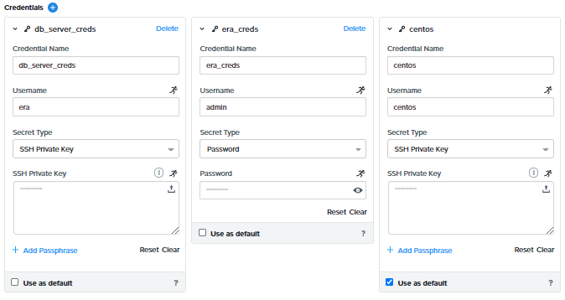

### Adapt the variables to suit your environment

1. Due to a bug in the credential macros for dynamic variables, we need to hardcode the credentials. The bug was expected to be fixed in Calm 3.3



1. Change the following dynamic variables:
   1. network_profile
   2. software_profile
   3. database_parameter
   4. compute_profile
2. Change the following variables:
   1. pc_password – Prism Central Password
   2. pc_username – Prism Central Username
   3. pc_ip – Prism Central IP
   4. era_ip – ERA IP
   5. db_name – Change the database name to suit the name you need

## Launch the blueprint

1. Fill in the following. Launch the application

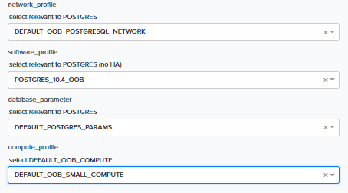

1. Login to ERA & observe the provisioning of the database.

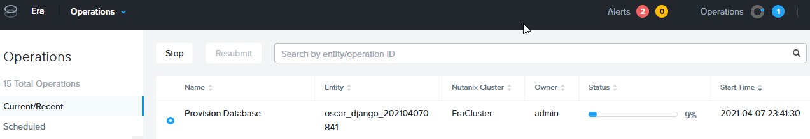

1. The application was launched successfully.

